ASSIGNMENT COVER SHEET

Student’s name | Isaac | Patrickson
Module name | Software Engineering Fundamentals
Title of assignment | Draft submission: Assignment report
Complete Word Count in my assignment | 1537 words
Date submitted

All work must be submitted by the due date. If an extension of time to submit work is required, a Mitigating Circumstances Extension Form must be submitted.

Has an extension been approved? Yes No If yes, please give the new submission date ….…/..…./…….

IMPORTANT: THIS STATEMENT MUST BE READ & SIGNED

Academic Integrity Statement

Academic integrity and honesty are fundamental to the academic work you produce at the University of Roehampton. You are expected to complete coursework that is your own and which is referenced appropriately. The university has in place measures to detect academic dishonesty in all its forms. If you are found to be cheating or attempting to gain an unfair advantage over other students in any way, this is considered academic misconduct and you will be penalised accordingly.
​
I declare that the work I am submitting is my work, is properly referenced and has not been submitted elsewhere.

Student Signature (Full Name): Isaac Patrickson

Date:

Table of Contents
Task 1: Design Document 3
Project Purpose Definition 3
Application Overview 3
Instructions 4
Use Case UML Diagram 9
Program Activity UML Diagram 10
Basic Class UML Diagram 11
Data Types and Validation Rules Specification 12
Program Structure 13
Task 3: Testing and the Manual Test Plan 14
Task 4: Review and Reflection 17
Appendices 18
Appendix 1 – Test Scripts as text 18
Test_main.py 18
Test_SQLQueries.py 20
Test_userClass.py 24
Appendix 2 – Source code as text 25
Main.py 25
initDatabase.py 38
clientClass.py 41
SQLQueries.py 43
userClass.py 46

Task 1: Design Document

Project Purpose Definition
Mediaworks Ltd is a digital marketing company that requires a readily available, editable record of all clients, both active and inactive that can demonstrate to new employees the journey Mediaworks has taken to achieve its current position. They believe sharing successful partnership stories with well-known brands can increase employee satisfaction by making Mediaworks a company they are proud to work for.

Application Overview
The application will use the SQLite library to create an embedded database that will store the data of Mediaworks clients in table records. Each record will have nine attributes: client ID, client name, contract status, contract start date, contract end date, whether project-based work is included in the contract, the longitude of the clients' HQ, the latitude of the clients' HQ, and the estimated total revenue generated. The client ID will be the primary key in the SQLite table and all requests to the table will be executed through a Python file.

SQLite is simple, self-contained and serverless. It is easy to set up and manage when compared to MySQL which requires a server. SQLite is lightweight and has a small footprint in terms of storage space and memory usage. This is important as employee devices may not be high-end machines. Zero configuration is needed therefore employees do not require configuration files or user authentication, simplifying deployment and management. For small to medium-sized databases, SQLite can be faster than MySQL due to its in-process architecture, reducing the overhead of client-server communication. SQLite is also a public domain software, which can simplify licensing concerns that Mediaworks may have.

The program should remove the need for curious employees to request internal reports which saves time within the business. It could also be used as a tool in the onboarding process to showcase the brilliance of Mediaworks to new employees.

Instructions
Run main.py in an IDE of your choice. On startup, the user will be prompted to log in with a username. Upon a successful login, they will be shown the entire contents of the table and then will be presented with an action menu. Depending on employee permissions, they will be given the option to amend, add, delete or display records. The user interface and the results of each request will be displayed to the user through the console. All inputs will be validated and all outputs will provide a clear description, to help create a user-friendly experience.
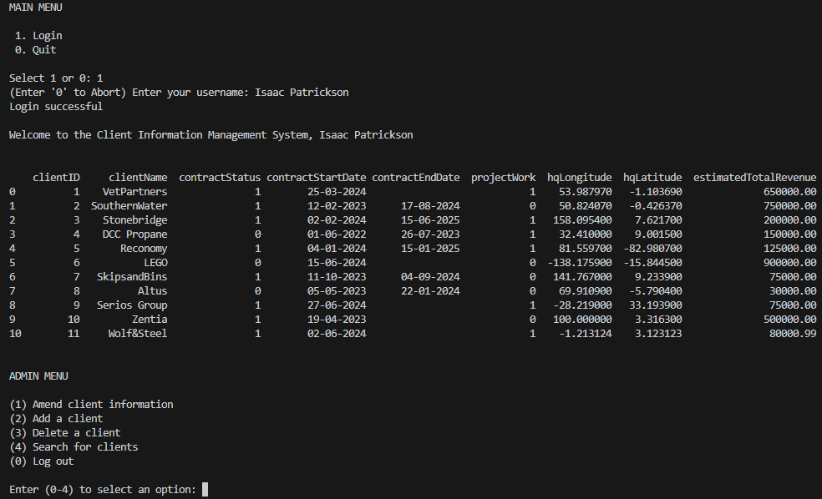
Upon selecting amend on the action menu, the user will be prompted to input a client ID linking to a record. The user will then need to select an attribute they would like to edit. Once an attribute is selected, they will need to input data to replace the existing data. The data is inserted into the selected place in the table, the table is displayed and the user is returned to the action menu. 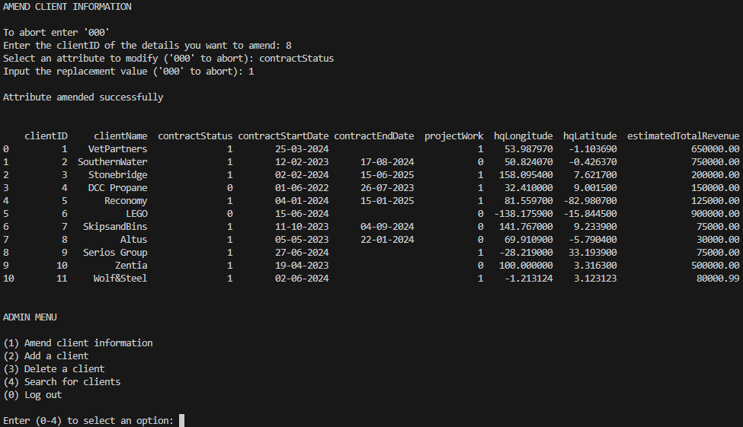
When adding a record, the user will be prompted to input data corresponding to each attribute in the table. Each input will be validated and stored in an array. Once the user has completed the data input process, a record will be created with the attributes the user has entered (client ID automatically assigned). The table will then be displayed, showing the new record, and the user will be returned to the action menu. 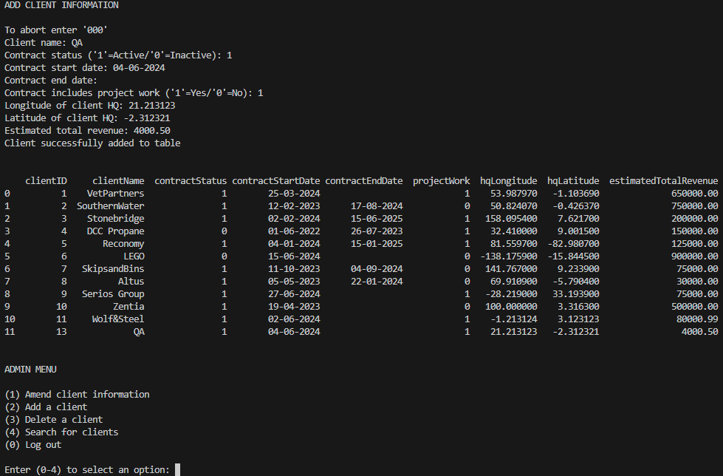
When deleting a record, the user will be prompted to enter a client ID. Since all client ID values are unique, this will help avoid accidental deletions. Confirmation will be required before the deletion. If the user confirms, the record will be deleted. The table will be displayed and the user will be returned to the action menu. Answering no will abort the process. After the process is aborted or completed, the user will return to the action menu. 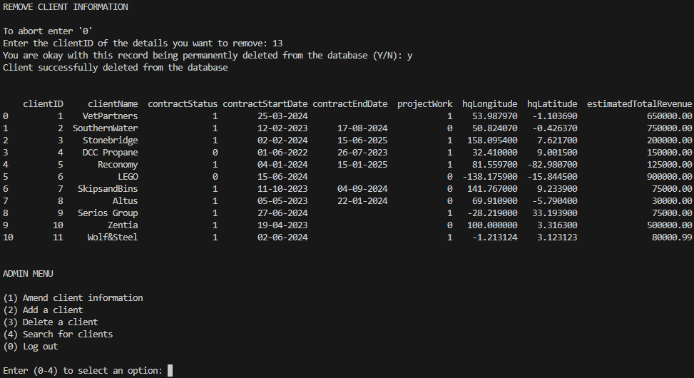

When displaying records, the user will be prompted to enter an attribute they would like to search by. The user is required to input their search data. Multiple records can be selected if the user decides to request based on a non-unique field (a user requesting for all active clients). All records that match the user's search will be displayed on screen and they will be prompted to either search again or return to the action menu. 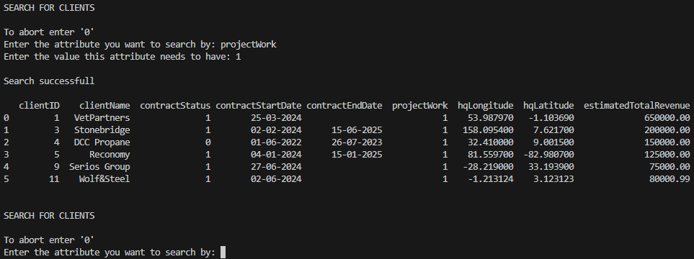

Use Case UML Diagram

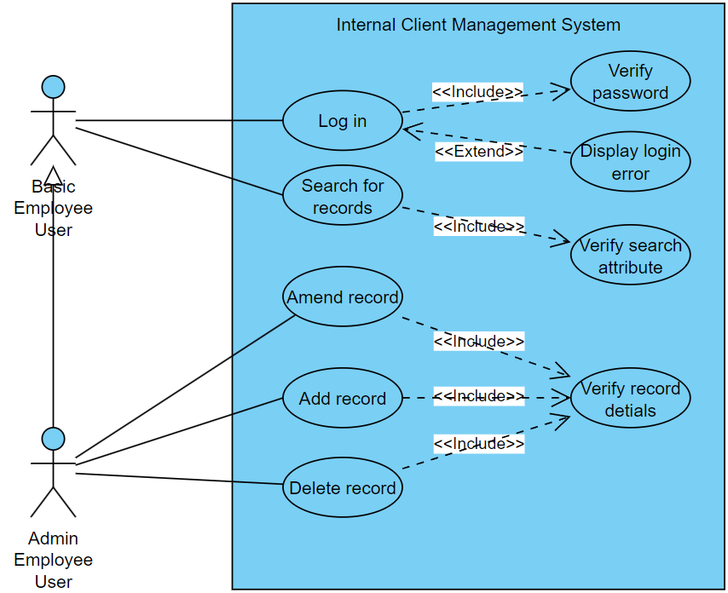

Program Activity UML Diagram
This Activity UML Diagram outlines the entire program (this activity diagram does not include the abort option for each user interaction stage)
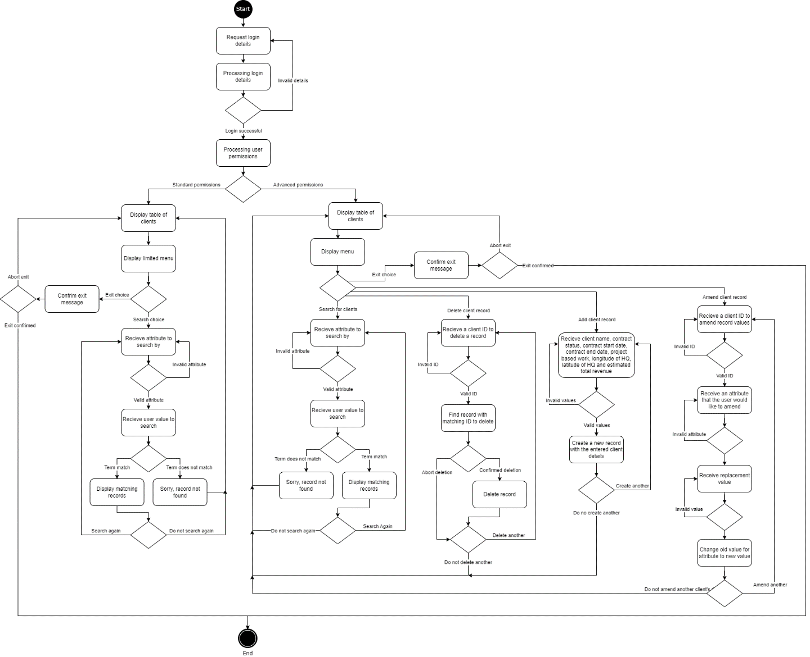

Basic Class UML Diagram
This Class UML Diagram highlights the attributes and methods in the classes, as well as the relationships between each class.

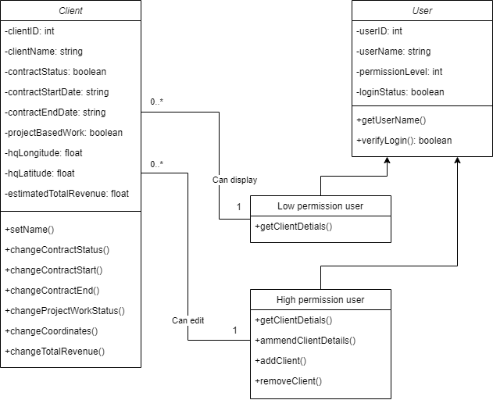
KEY
 | Is a child of…
 | 0 or many to one
- | Private
+ | Public

Data Types and Validation Rules Specification
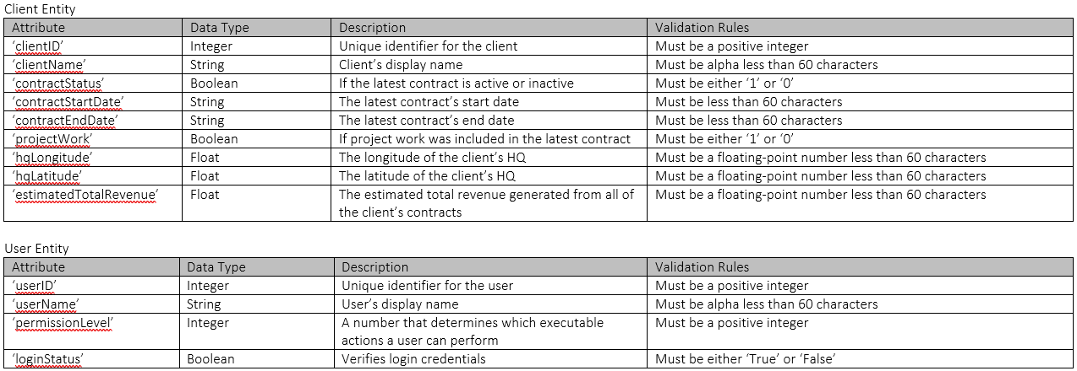

Program Structure
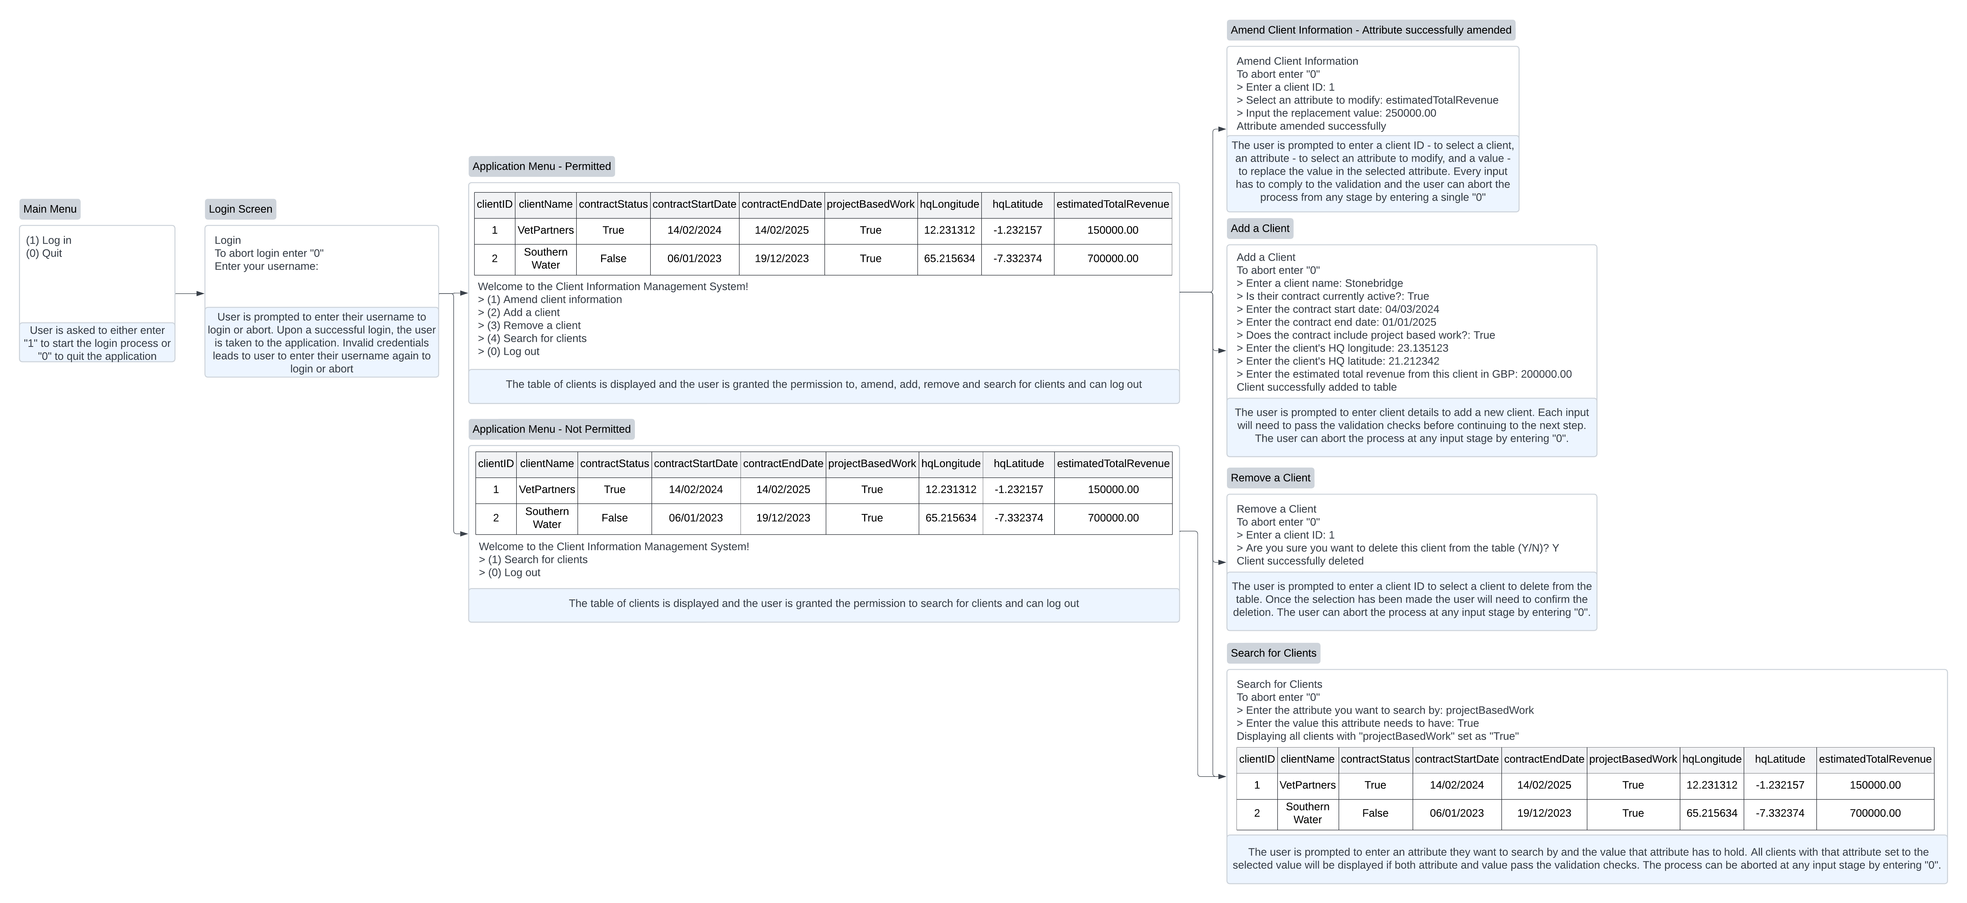

Task 3: Testing and the Manual Test Plan
During the development phase, I conducted manual testing which helped me evaluate the user experience. Manual testing's exploratory nature enabled me to quickly discover unexpected issues. After I had completed the main development phase, I used pytest to develop unit tests. Manual testing proved to be tedious and automated unit testing ensured that the tests were consistent and proved to be quicker than manual testing. Writing the unit tests was less time-consuming and less error-prone when compared to manual testing. The unit tests covered critical processes ensuring robustness throughout my program. Conducting the unit tests after development helped me verify that individual components of the code functioned as expected and highlighted areas that I had to rework. Overall, the combination of both automated and manual testing ensured a nice balance between efficiency and thoroughness. See Appendix 1 – test scripts to view the test scripts.

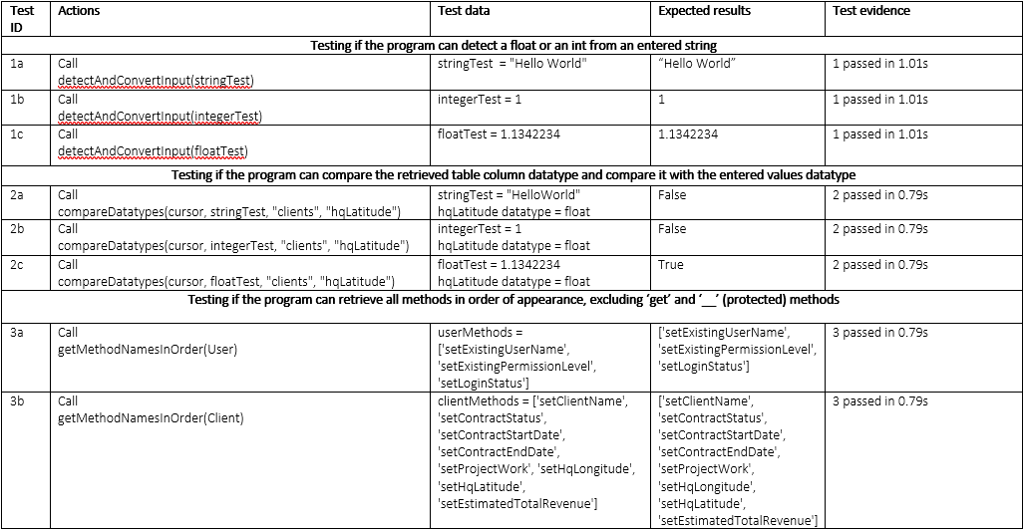
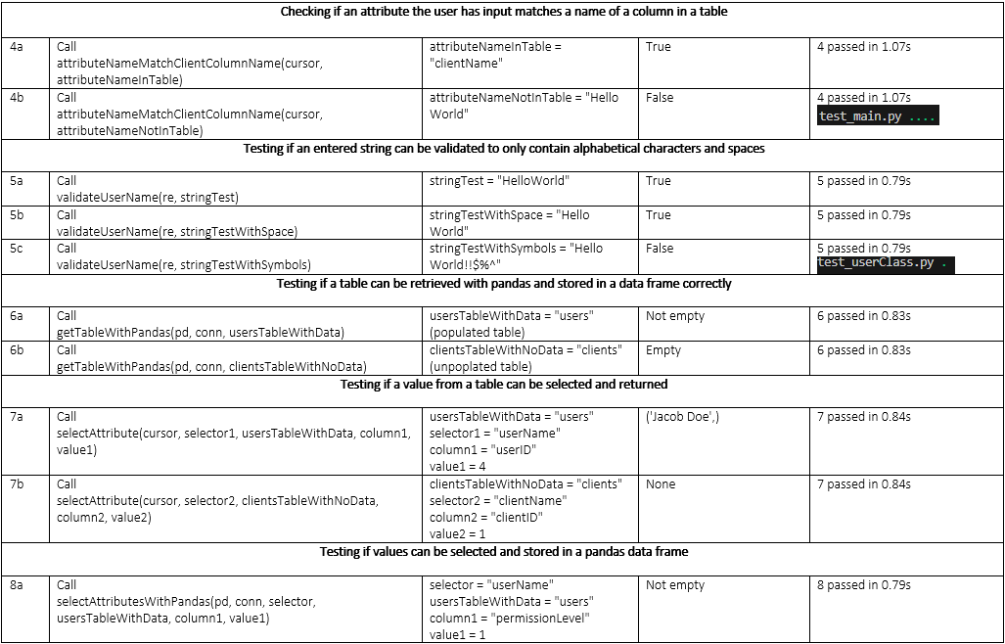
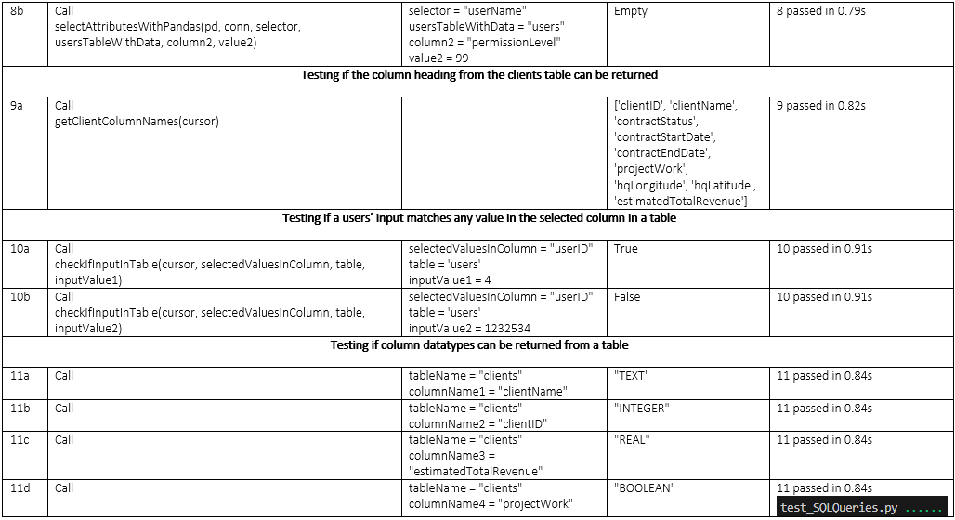

Task 4: Review and Reflection
I believe I have completed the task of developing a console-based application that uses a method of storage to amend, add, delete and display records. The amend, add, delete and display functions closely align with the CRUD (Create, Read, Update, Delete) operations. Using my experience with SQL, I built a Python program that can execute the INSERT, SELECT, UPDATE and DELETE records from a previously initialised database file, made possible by the SQLite3 package. In addition to fulfilling the specification requirements, I created a separate table that stored user information. Depending on the user's permission level, only specific CRUD operations would be available to them.

During the design phase, I created UML diagrams. These proved to be useful for clearly defining the requirements of the program and also functioned as a reference throughout the development phase. During development, I would occasionally attempt to add new features, but the UML diagrams kept me on track and eliminated the risk of scope creep. Before starting the development phase, I aimed to code following the agile methodology. I delivered each CRUD operation one at a time and used Bitbucket and SourceTree as a method of source control. Every push I made to the main repository marked a deliverable goal in the development stage.

Although its use was a requirement, python is a perfect language for creating a back-end storage program. There were libraries (pandas, SQLite3, re, Inspect, etc..) that aided in the development phase of the project. If the project were to deal with larger datasets, python would allow the use of a MySQL server to become a main method of storage, replacing SQLite3.

The strengths of this project are the use of SQLite3, the object-oriented approach and the use of source control. Using SQLite3 instead of a dictionary allowed for complex data tables with varying datatypes per column to be created. One command can create a table with predefined rules and a primary key that automatically increments, which saves time compared to manually creating rules for a dictionary storage system. Libraries such as Pandas can also provide easy and clean ways to display the created tables. The object-oriented approach to gathering user and client data allows for easy scalability and the ability to set default values if desired in the future. The use of Bitbucket allowed for effective source control and descriptive changelogs. Fatal mistakes were not detrimental to the program as rolling back to a previous version was simple.

The weaknesses of this project are the lack of security, the lack of test-driven development and the struggle to keep the agile methodology. Upon testing the program, I wrote unit tests with pytest. I learned that these unit tests can be written before the code has been developed which can function as a success metric while also testing the robustness of the program. Following the test-driven methodology would have potentially shortened the development phase as less manual testing would be needed. The need to manually test throughout the development phase did not follow the Agile methodology. Spending time on extensive validation, in the beginning, to make sure user input from the manual tests didn't fail further distanced the development phase from following agile. The addition of the users table and a login feature created opportunities for security in the program. For quickness and to not exceed the requirements too much, the login only asks for a username. This is not a secure way for users to log in. To further boost security, I would include the requirement of a password and use a hashing algorithm to create hash keys and hashed passwords for each user to avoid storing passwords.

Appendices

Appendix 1 – Test Scripts as text

Test_main.py
import sqlite3
import pytest
from main import *

@pytest.fixture
def dbConnection():
# Setup: creates a temporary in-memory database and table
conn = sqlite3.connect(":memory:")
cursor = conn.cursor()
cursor.execute("""CREATE TABLE users(
userID INTEGER PRIMARY KEY AUTOINCREMENT,
userName TEXT NOT NULL,
permissionLevel INT NOT NULL
)""")
cursor.execute("""CREATE TABLE clients(
clientID INTEGER PRIMARY KEY AUTOINCREMENT,
clientName TEXT NOT NULL,
contractStatus BOOLEAN NOT NULL,
contractStartDate TEXT,
contractEndDate TEXT,
projectWork BOOLEAN NOT NULL,
hqLongitude REAL,
hqLatitude REAL,
estimatedTotalRevenue REAL
)""")
conn.commit()
yield conn, cursor # Provides the connection and cursor to the test
# Teardown: closes the cursor and connection
cursor.close()
conn.close()

def testCompareDatatypes(dbConnection):
conn, cursor = dbConnection
stringTest = "HelloWorld"
integerTest = 1
floatTest = 1.1342234
assert compareDatatypes(cursor, stringTest, "clients", "hqLatitude") == False
assert compareDatatypes(cursor, integerTest, "clients", "hqLatitude") == False
assert compareDatatypes(cursor, floatTest, "clients", "hqLatitude") == True

def testDetectAndConvertInput():
stringTest = "HelloWorld"
integerTest = 1
floatTest = 1.1342234
assert detectAndConvertInput(stringTest) == "HelloWorld"
assert detectAndConvertInput(integerTest) == 1
assert detectAndConvertInput(floatTest) == 1.1342234

def testGetMethodNamesInOrder():
userMethods = ['setExistingUserName', 'setExistingPermissionLevel', 'setLoginStatus']
clientMethods = ['setClientName', 'setContractStatus', 'setContractStartDate',
'setContractEndDate', 'setProjectWork', 'setHqLongitude',
'setHqLatitude', 'setEstimatedTotalRevenue']
assert getMethodNamesInOrder(User) == userMethods
assert getMethodNamesInOrder(Client) == clientMethods

def testAttributeNameMatchClientColumnName(dbConnection):
conn, cursor = dbConnection
attributeNameInTable = "clientName"
attributeNameNotInTable = "Hello World"
assert attributeNameMatchClientColumnName(cursor, attributeNameInTable) == True
assert attributeNameMatchClientColumnName(cursor, attributeNameNotInTable) == False

Test_SQLQueries.py
import sqlite3
import pytest
import pandas as pd
from main import *

@pytest.fixture
def dbConnection():
# Setup: creates a temporary in-memory database and table
conn = sqlite3.connect(":memory:")
cursor = conn.cursor()
cursor.execute("""CREATE TABLE users(
userID INTEGER PRIMARY KEY AUTOINCREMENT,
userName TEXT NOT NULL,
permissionLevel INT NOT NULL
)""")
cursor.execute("""CREATE TABLE clients(
clientID INTEGER PRIMARY KEY AUTOINCREMENT,
clientName TEXT NOT NULL,
contractStatus BOOLEAN NOT NULL,
contractStartDate TEXT,
contractEndDate TEXT,
projectWork BOOLEAN NOT NULL,
hqLongitude REAL,
hqLatitude REAL,
estimatedTotalRevenue REAL
)""")

columns = ["userName", "permissionLevel"]
rows = [
('Isaac Patrickson', 9),
('John Doe', 1),
('Jane Doe', 2),
('Jacob Doe', 3),
('Jamie Doe', 4),
('Jonathan Doe', 5),
('Jemima Doe', 6),
('Jade Doe', 7),
('Jasper Doe', 8),
('Jessie Doe', 1)
]

for row in rows:
query = f"INSERT INTO users ({', '.join(columns)}) VALUES ({', '.join(['?' for _ in columns])})"
try:
cursor.execute(query, row)
except:
print("Hardcoded values corrupted, corrupted records may be skipped")

conn.commit()

yield conn, cursor # Provides the connection and cursor to the test
# Teardown: closes the cursor and connection
cursor.close()
conn.close()

def testGetTableWithPandas(dbConnection):
conn, cursor = dbConnection
usersTableWithData = "users"
clientsTableWithNoData = "clients"
populatedTable = getTableWithPandas(pd, conn, usersTableWithData)
nonPopulatedTable = getTableWithPandas(pd, conn, clientsTableWithNoData)
assert not populatedTable.empty
assert nonPopulatedTable.empty

def testSelectAttribute(dbConnection):
conn, cursor = dbConnection
usersTableWithData = "users"
selector1 = "userName"
column1 = "userID"
value1 = 4

clientsTableWithNoData = "clients"
selector2 = "clientName"
column2 = "clientID"
value2 = 1
assert selectAttribute(cursor, selector1, usersTableWithData, column1, value1) == ('Jacob Doe',)
assert selectAttribute(cursor, selector2, clientsTableWithNoData, column2, value2) == None

def testSelectAttributesWithPandas(dbConnection):
conn, cursor = dbConnection
selector = "userName"
usersTableWithData = "users"
column1 = "permissionLevel"
value1 = 1
column2 = "permissionLevel"
value2 = 99
populatedTable = selectAttributesWithPandas(pd, conn, selector, usersTableWithData, column1, value1)
nonPopulatedTable = selectAttributesWithPandas(pd, conn, selector, usersTableWithData, column2, value2)
assert not populatedTable.empty
assert nonPopulatedTable.empty

def testGetClientColumnNames(dbConnection):
conn, cursor = dbConnection
assert getClientColumnNames(cursor) == ['clientID', 'clientName', 'contractStatus',
'contractStartDate', 'contractEndDate', 'projectWork',
'hqLongitude', 'hqLatitude', 'estimatedTotalRevenue']

def testCheckIfInputInTable(dbConnection):
conn, cursor = dbConnection
selectedValuesInColumn = "userID"
table = 'users'
inputValue1 = 4
inputValue2 = 1232534
assert checkIfInputInTable(cursor, selectedValuesInColumn, table, inputValue1) == True
assert checkIfInputInTable(cursor, selectedValuesInColumn, table, inputValue2) == False

def testGetColumnDataType(dbConnection):
conn, cursor = dbConnection
tableName = "clients"
columnName1 = "clientName"
columnName2 = "clientID"
columnName3 = "estimatedTotalRevenue"
columnName4 = "projectWork"
assert getColumnDataType(cursor, tableName, columnName1) == "TEXT"
assert getColumnDataType(cursor, tableName, columnName2) == "INTEGER"
assert getColumnDataType(cursor, tableName, columnName3) == "REAL"
assert getColumnDataType(cursor, tableName, columnName4) == "BOOLEAN"

Test_userClass.py
import pytest
import re
from userClass import *

def testValidateUserName():
stringTest = "HelloWorld"
stringTestWithSpace = "Hello World"
stringTestWithSymbols = "Hello World!!$%^"
assert validateUserName(re, stringTest) == True
assert validateUserName(re, stringTestWithSpace) == True
assert validateUserName(re, stringTestWithSymbols) == False

Appendix 2 – Source code as text

Main.py
import sqlite3
import pandas as pd
import re
from itertools import zip_longest
import inspect
import ast
from SQLiteDatabase.InitDatabase import *
from SQLQueries import *
from userClass import *
from clientClass import *

# Connect to a (new) database
def conntectToDatabase():
try:
connection = sqlite3.connect("SQLiteDatabase/mediaworksUsersAndClients.db")
return connection
except sqlite3.OperationalError as e:
print(f"An error occurred: {e}")

# Login menu is the main branch of the program
# The login process is executed
# and depending on the user permissions different options are presented
def main():
connection = conntectToDatabase()
cursor = connection.cursor()
# Functions that create the 'users' and the 'clients' table
createUsersTable(cursor)
createClientsTable(cursor)

# Check if the tables are already populated and hardcode values accordingly
hardcodeValues(cursor, isTablePopulated(sqlite3, cursor, "users")
and isTablePopulated(sqlite3, cursor, "clients"))
# This while loop will help validate the user's choice of action at the Login Menu
# 'loginMenuValid' is True when the user has successfully entered a valid choice
# and the loop ends
loginMenuValid = False
while loginMenuValid == False:
print()
print("MAIN MENU")
print()
print(" 1. Login")
print(" 0. Quit")
print()
choice = input("Select 1 or 0: ")
# User enters '1' and is prompted to ennter a username to log in
if choice == "1":
loginMenuValid = True
login = User()
# This while loop will help validate the user's username
# If the username is not alpha (spaces included)
# and the username is not in the database, the user will be prompted to enter a username again
userNameInput = False
while userNameInput == False:
inputName = input("(Enter '0' to Abort) Enter your username: ")
if validateUserName(re, inputName):
if isUserNameInTable(selectAttribute(cursor, "userName", "users", "userName", inputName)):
userNameInput = True
login.setExistingUserName(inputName)
login.setLoginStatus(True)
print("Login successful")
print()
print(f"Welcome to the Client Information Management System, {inputName}")
else:
print("An error occurred: The entered username is not in our database")
else:
if inputName == "0":
userNameInput = True
loginMenuValid = False
print("Login aborted")
else:
print("An error occurred: Username must contain alpha characters (spaces included)")

# Systems checks if user has successfully logged in
# and displays the 'clients' table using the pandas package
while login.getLoginStatus() == True:
permissionLevel = []
clientsTable = getTableWithPandas(pd, connection, "clients")
print()
print()
print(clientsTable)

# The permission value for the logged in user is retrieved from the 'users' table and stored in a list
# and a for loop retrieves the value
# A for loop needs to be used as the permission value is stored in a tuple even though it is just one value
permissionValues = selectAttribute(cursor, "permissionLevel", "users", "userName", inputName)
for permissionValue in permissionValues:
login.setExistingPermissionLevel(permissionValue)

# If the user's permission value is greated than or equal to 5 they are presented the Admin menu
# Admins can amend, add, delete and search for clients
# Both admin and employee can log out
permissionLevel = login.getPermissionLevel()
if permissionLevel >= 5:
# A while loop that validates the users input on the menu screen
validChoice = False
while validChoice == False:
choice = []
print()
print()
print("ADMIN MENU")
print()
print("(1) Amend client information")
print("(2) Add a client")
print("(3) Delete a client")
print("(4) Search for clients")
print("(0) Log out")
print()
choice = input("Enter (0-4) to select an option: ")
# Each choice (except log out) calls a function
# corresponding to the action the user wants to execute
if choice == "1":
validChoice = True
amendClientInformation(cursor)
elif choice == "2":
validChoice = True
addClient(cursor)
elif choice == "3":
validChoice = True
removeClient(cursor)
elif choice == "4":
validChoice = True
searchClients(connection, cursor)
elif choice == "0":
validChoice = True
print()
print("Log out successful")
login.setLoginStatus(False)
else:
print("An error occurred: Input must be an integer between (0-4)")

# If the user's permission value is less than 5 they are presented the Employee menu
# Employees can search for clients
elif permissionLevel < 5:
# A while loop that validates the users input on the menu screen
validChoice = False
while validChoice == False:
choice = []
print()
print()
print("EMPLOYEE MENU")
print()
print("(1) Search for clients")
print("(0) Log out")
print()
choice = input("Enter (0-1) to select an option: ")
if choice == "1":
validChoice = True
searchClients(connection, cursor)
elif choice == "0":
validChoice = True
print()
login.setLoginStatus(False)
else:
print("An error occurred: Input must be an integer between (0-1)")
loginMenuValid = False

# If the User has chosen to exit the program, the program will start the exit process
elif choice == "0":
# This while loop asks the user if they are sure if they want to exit the program
# user input is validated
sureValid = False
while sureValid == False:
isUserSure = input("You are okay with exiting the system (Y/N): ")
if isUserSure.upper() == "Y":
sureValid = True
loginMenuValid = True
break
elif isUserSure.upper() == "N":
sureValid = True
print()
print("Exit aborted")
else:
print(f"An error occurred: {isUserSure} is not 'Y' or 'N'")
# If the user did not input a '1' to log in or a '0' to exit
# they are prompted to enter either a '1' or a '0'
else:
print("An error occurred: Input must be an integer (0-1)")

# Committing all changes to the database once the user has decided to exit the system
# If for whatever reason the system stops before the user exits
# all changes will be reverted
connection.commit()

# Close connection
connection.close()
print("System exit successful")
exit()

def amendClientInformation(cursor):
# A while loop that validates the user input on the amend menu
ammendOptionValid = False
while ammendOptionValid == False:
abort = False
print()
print()
print("AMEND CLIENT INFORMATION")
print()
print("To abort enter '000'")
iDofClientToAmend = input("Enter the clientID of the details you want to amend: ")
if iDofClientToAmend == "000":
ammendOptionValid = True
print("Amend process aborted")
# Client ID is in the table therefore the amend process continues
# The user should not be able to amend a record that doesn't exist
elif checkIfInputInTable(cursor, "clientID", "clients", iDofClientToAmend) == True:
fieldToModify = input("Select an attribute to modify ('000' to abort): ")
# ClientID cannot be modified as it is the unique identifier for each record
if fieldToModify == "clientID":
print()
print(f"An error occurred: {fieldToModify} is the primary key, this cannot be modified")
# If the field the user chose to amend matches a column name in the 'clients' table
# and is not 'clientID' the user will be asked to enter a replacement value
# The system checks if this value's datatype matches the column's datatype
# If they match the value is valid to be updated
elif attributeNameMatchClientColumnName(cursor, fieldToModify):
replacementValue = input("Input the replacement value ('000' to abort): ")
if replacementValue == "000":
ammendOptionValid = True
print()
print("Add process aborted")
# The answer must be 60 characters or less
elif len(replacementValue) > 60:
print("The length of each answer must be below 60 characters")
elif compareDatatypes(cursor, replacementValue, "clients", fieldToModify):
# If the datatype is BOOLEAN the replacement value must either be '1' or '0'
if getColumnDataType(cursor, "clients", fieldToModify) == "BOOLEAN":
while replacementValue != "1" and replacementValue != "0":
replacementValue = input("Replacement value for for BOOLEAN fileds must be '1' or '0' ('000' to abort): ")
if replacementValue == "000":
ammendOptionValid = True
abort = True
print()
print("Add process aborted")
if abort == False:
replaceAttribute(cursor, "clients", fieldToModify, replacementValue, "clientID", iDofClientToAmend)
print()
print("Attribute amended successfully")
ammendOptionValid = True
else:
print(f"An error occurred: The datatype of {replacementValue} does not match the datatype of that field")
elif checkIfInputInTable(cursor, "clientID", "clients", iDofClientToAmend) == False:
print(f"An error occurred: {iDofClientToAmend} does not exist as a clientID in the clients table")
else:
print(f"An error occurred: {iDofClientToAmend} is an invalid clientID! A clientID must be an integer")

def addClient(cursor):
# A while loop that validates the user input on the add menu
addProcessComplete = False
while addProcessComplete == False:
print()
print()
print("ADD CLIENT INFORMATION")
print()
print("To abort enter '000'")
clientToAdd = Client()
# Gathering all the column names excluding clientID
# ClientID is incremented automatically
# The user does not need to input a clientID
columnNames = getClientColumnNames(cursor)
for columnName in columnNames:
if columnName == "clientID":
columnNames.remove(columnName)
else:
pass
# Creating a list of questions relating to each column name
questions = [
"Client name: ",
"Contract status ('1'=Active/'0'=Inactive): ",
"Contract start date: ",
"Contract end date: ",
"Contract includes project work ('1'=Yes/'0'=No): ",
"Longitude of client HQ: ",
"Latitude of client HQ: ",
"Estimated total revenue: "
]
# Getting all the 'Client' methods in order of appearance
methods = getMethodNamesInOrder(Client)
# Merging all three lists into one list
# Each item in the new list contains a list containing three items
# The length of the new merged list will be the length of the shortest list
# This shouldn't be a problem as all lists should be the same length
# This is just a precaution and makes the code more robust
mergedColNamesQuestionsMethods = [[a, b, c] for a, b, c in zip_longest(columnNames, questions, methods)]
# For each item in the new list, gather an input by asking the question
# stored in the merged list value
abort = False
for ColQuestionMethod in mergedColNamesQuestionsMethods:
answerValid = False
while answerValid == False:
answer = input(ColQuestionMethod[1])
# If the answer is '000' the process is aborted
# I chose to use '000' instead of '0' as '0'
# because '0' can be a valid and common input for a client value
if answer == "000":
answerValid = True
abort = True
print()
print("Add process aborted")
# The answer must be 60 characters or less
elif len(answer) > 60:
print("The length of each answer must be below 60 characters")
# The datatype of the answer must match the column
# The corresponding column is retrieved from the merged list item
elif compareDatatypes(cursor, answer, "clients", ColQuestionMethod[0]):
answerValid = True
method = getattr(clientToAdd, ColQuestionMethod[2])
method(answer)
else:
print("The datatype of the answer you entered does not match the field")
if abort:
addProcessComplete = True
break

# If the user has not aborted, the attribute values are retrieved
# from the 'clientToAdd' instance of Client
# The values are inserted into the 'clients' table, forming a new client record
if abort == False:
answerValues = [clientToAdd.getClientName(),
clientToAdd.getContractStatus(),
clientToAdd.getContractStartDate(),
clientToAdd.getContractEndDate(),
clientToAdd.getProjectBasedWork(),
clientToAdd.getHqLongitude(),
clientToAdd.getHqLatitude(),
clientToAdd.getEstimatedTotalRevenue()]
insertInto(cursor, "clients", columnNames, answerValues)
print("Client successfully added to table")
addProcessComplete = True

def removeClient(cursor):
# A while loop that validates the user input on the remove menu
removeOptionValid = False
while removeOptionValid == False:
print()
print()
print("REMOVE CLIENT INFORMATION")
print()
print("To abort enter '0'")
iDofClientToRemove = input("Enter the clientID of the details you want to remove: ")
if iDofClientToRemove == "0":
removeOptionValid = True
print()
print("Delete process aborted")
# Client ID is in the table therefore the delete process continues
# The user should not be able to delete a record that doesn't exist
elif checkIfInputInTable(cursor, "clientID", "clients", iDofClientToRemove) == True:
removeOptionValid = True
# This while loop asks the user if they are sure if they want to delete the selected record
# user input is validated
sureValid = False
while sureValid == False:
isUserSure = input("You are okay with this record being permanently deleted from the database (Y/N): ")
if isUserSure.upper() == "Y":
sureValid = True
removeRecord(cursor, "clients", "clientID", iDofClientToRemove)
print("Client successfully deleted from the database")
elif isUserSure.upper() == "N":
sureValid = True
print()
print("Delete process aborted")
else:
print(f"An error occurred: {isUserSure} is not 'Y' or 'N'")

elif checkIfInputInTable(cursor, "clientID", "clients", iDofClientToRemove) == False:
print(f"An error occurred: {iDofClientToRemove} does not exist as a clientID in the clients table")
else:
print(f"An error occurred: {iDofClientToRemove} is an invalid clientID! A clientID must be an integer")

def searchClients(connection, cursor):
# A while loop that validates the user input on the search menu
searchOptionValid = False
while searchOptionValid == False:
print()
print()
print("SEARCH FOR CLIENTS")
print()
print("To abort enter '0'")
attributeToSearchBy = input("Enter the attribute you want to search by: ")
if attributeToSearchBy == "0":
searchOptionValid = True
print("Search process aborted")
# If the process has not been aborted and the input attribute name (aka field name)
# matches a column name in the table the process continues
elif attributeNameMatchClientColumnName(cursor, attributeToSearchBy) == True:
valueToSearchFor = input("Enter the value this attribute needs to have: ")
# The search results are stored in 'searchResults' using pandas
searchResults = str(selectAttributesWithPandas(pd, connection, "*", "clients", attributeToSearchBy, valueToSearchFor))
# If 'searchResults' is not empty, display the table of search results
if "Empty DataFrame" not in searchResults:
print()
print("Search successfull")
print()
print(searchResults)
# If the table is empty, display search error message
else:
print()
print("An error occurred: No results match that search")
elif attributeNameMatchClientColumnName(cursor, attributeToSearchBy) == False:
print("An error occurred: The attribute you have selected does not exist as a column in the clients table")
else:
print(f"An error occurred: {attributeToSearchBy} is an invalid attribute name")

def compareDatatypes(cursor, inputValue, tableName, columnName):
columnDatatype = getColumnDataType(cursor, tableName, columnName)
# A dictionary that assings a SQLite column datatype to a usable python datatype
datatypeMap = {
"INTEGER": int,
"BOOLEAN": int,
"TEXT": str,
"REAL": float,
"BLOB": bytes,
"NUMERIC": float
}
# Check if the input value can be represented as an int or a float
# before assuming its always a string
convertedInputValue = detectAndConvertInput(inputValue)
# If types match return true
# If types do not match return false
inputDatatype = type(convertedInputValue)
if inputDatatype == datatypeMap.get(columnDatatype.upper()):
return True
else:
return False

def detectAndConvertInput(userInput):
try:
# Try to convert the input to a float first
float_value = float(userInput)
# Check if the float value can be represented as an integer
if float_value.is_integer():
return int(float_value)
else:
return float_value
except ValueError:
# If conversion to float fails, return the input as a string
return userInput

def getMethodNamesInOrder(className):
# Uses the inspect package to inspect a class
source = inspect.getsource(className)
# Stores the classes methods and relationships in a 'tree'
tree = ast.parse(source)
# Navigating the tree to get methods that are not protected or getters
methods = [node.name for node in tree.body[0].body
if isinstance(node, ast.FunctionDef)
and not node.name.startswith("__")
and not node.name.startswith("get")]
return methods

# Checks if an input attribute name (aka field name) matches a colum in a table
def attributeNameMatchClientColumnName(cursor, attributeName):
columnNames = getClientColumnNames(cursor)
for columnName in columnNames:
if attributeName == columnName:
return True
else:
pass
return False

if __name__ == "__main__":
main()

initDatabase.py
def createUsersTable(cursor):
# Create 'users' table
initUsersTable = """CREATE TABLE IF NOT EXISTS users(
userID INTEGER PRIMARY KEY AUTOINCREMENT,
userName TEXT NOT NULL,
permissionLevel INT NOT NULL
)"""
# Executing the command that creates the 'users' table
cursor.execute(initUsersTable)

def createClientsTable(cursor):
# Create 'clients' table
initClientsTable = """CREATE TABLE IF NOT EXISTS clients(
clientID INTEGER PRIMARY KEY AUTOINCREMENT,
clientName TEXT NOT NULL,
contractStatus BOOLEAN NOT NULL,
contractStartDate TEXT,
contractEndDate TEXT,
projectWork BOOLEAN NOT NULL,
hqLongitude REAL,
hqLatitude REAL,
estimatedTotalRevenue REAL
)"""
# Executing the command that creates the 'clients' table
cursor.execute(initClientsTable)

def isTablePopulated(sqlite3, cursor, tableName):
# SQL query to count the number of rows in the table
query = f"SELECT COUNT(*) FROM {tableName}"

try:
# Execute the query
cursor.execute(query)

# Fetch the result
count = cursor.fetchone()[0]

# Check if the table is populated
if count > 0:
return 1
else:
return 0
except sqlite3.OperationalError as e:
# Handle case where the table does not exist
print(f"An error occurred: {e}")
return 0

def hardcodeValues(cursor, populated):
if populated:
pass
else:
# Add to 'users'
# Defining 'users' columns and data to insert
columns = ["userName", "permissionLevel"]
rows = [
('Isaac Patrickson', 9),
('John Doe', 1),
('Jane Doe', 2),
('Jacob Doe', 3),
('Jamie Doe', 4),
('Jonathan Doe', 5),
('Jemima Doe', 6),
('Jade Doe', 7),
('Jasper Doe', 8),
('Jessie Doe', 1)
]
# Add each record to the table one at a time
# If the hardcode data is corrupted
# the insert process will skip the data that causes an error
# and continue on to the next record
for row in rows:
query = f"INSERT INTO users ({', '.join(columns)}) VALUES ({', '.join(['?' for _ in columns])})"
try:
cursor.execute(query, row)
except:
print("Hardcoded values corrupted, corrupted records may be skipped")

# Add to 'clients'
# Defining 'clients' columns and data to insert
columns = ["clientName", "contractStatus", "contractStartDate", "contractEndDate", "projectWork", "hqLongitude", "hqLatitude", "estimatedTotalRevenue"]
rows = [
('VetPartners', '1', '25-03-2024', '', '1', 53.98797, -1.10369, 650000.00),
('SouthernWater', '1', '12-02-2023', '17-08-2024', '0', 50.82407, -0.42637, 750000.00),
('Stonebridge', '1', '02-02-2024', '15-06-2025', '1', 158.0954, 7.6217, 200000.00),
('DCC Propane', '0', '01-06-2022', '26-07-2023', '1', 32.4100, 9.0015, 150000.00),
('Reconomy', '1', '04-01-2024', '15-01-2025', '1', 81.5597, -82.9807, 125000.00),
('LEGO', '0', '15-06-2024', '', '0', -138.1759, -15.8445, 900000.00),
('SkipsandBins', '1', '11-10-2023', '04-09-2024', '0', 141.7670, 9.2339, 75000.00),
('Altus', '0', '05-05-2023', '22-01-2024', '0', 69.9109, -5.7904, 30000.00),
('Serios Group', '1', '27-06-2024', '', '1', -28.2190, 33.1939, 75000.00),
('Zentia', '1', '19-04-2023', '', '1', 97.0081, 3.3163, 500000.00)
]
# Add each record to the table one at a time
# If the hardcode data is corrupted
# the insert process will skip the data that causes an error
# and continue on to the next record
for row in rows:
query = f"INSERT INTO clients ({', '.join(columns)}) VALUES ({", ".join(['?' for _ in columns])})"
try:
cursor.execute(query, row)
except:
print("Hardcoded values corrupted, corrupted records may be skipped")

clientClass.py
class Client():

def __init__(self) -> None:
# Initialize a new 'Client' instance with default values
self._clientId = []
self._clientName = []
self._contractStatus = []
self._contractStartDate = []
self._contractEndDate = []
self._projectWork = []
self._hqLongitude = []
self._hqLatitude = []
self._estimatedTotalRevenue = []

def setClientName(self, clientName):
self._clientName = clientName

def setContractStatus(self, contractStatus):
self._contractStatus = contractStatus

def setContractStartDate(self, contractStartDate):
self._contractStartDate = contractStartDate

def setContractEndDate(self, contractEndDate):
self._contractEndDate = contractEndDate

def setProjectWork(self, projectWork):
self._projectWork = projectWork

def setHqLongitude(self, hqLongitude):
self._hqLongitude = hqLongitude

def setHqLatitude(self, hqLatitude):
self._hqLatitude = hqLatitude

def setEstimatedTotalRevenue(self, estimatedTotalRevenue):
self._estimatedTotalRevenue = estimatedTotalRevenue

def getClientName(self):
return self._clientName

def getContractStatus(self):
return self._contractStatus

def getContractStartDate(self):
return self._contractStartDate

def getContractEndDate(self):
return self._contractEndDate

def getProjectBasedWork(self):
return self._projectWork

def getHqLongitude(self):
return self._hqLongitude

def getHqLatitude(self):
return self._hqLatitude

def getEstimatedTotalRevenue(self):
return self._estimatedTotalRevenue

SQLQueries.py
# Using pandas to return a formatted table that can neatly displayed in the console
def getTableWithPandas(pd, connection, table):
neatTable = pd.read_sql_query(f"SELECT * FROM {table}", connection)
return neatTable

# Reusable SQL select command
def selectAttribute(cursor, selector, table, column, value):
query = f"SELECT {selector} FROM {table} WHERE {column} = ?"
cursor.execute(query, (value,))
result = cursor.fetchone()
return result

# Using pandas to select specific records in a table
# Used for search function
def selectAttributesWithPandas(pd, connection, selector, table, column, value):
query = f"SELECT {selector} FROM {table} WHERE {column} = ?"
results = pd.read_sql_query(query, connection, params=(value,))
return results

# Reusable SQL command that gets all the column names in a table
def getClientColumnNames(cursor):
cursor.execute("""SELECT clientID, clientName, contractStatus, contractStartDate,
contractEndDate, projectWork, hqLongitude, hqLatitude, estimatedTotalRevenue
FROM clients""")
# Fetch the column names
columnNames = [description[0] for description in cursor.description]
return columnNames

# Selects all records from a table that matches the users input value
def checkIfInputInTable(cursor, selectedValuesInColumn, table, inputValue):
query = f"SELECT {selectedValuesInColumn} FROM {table}"
cursor.execute(query)
results = cursor.fetchall()
for result in results:
if str(inputValue) == str(result[0]):
return True
else:
pass
return False

# Update an attribute value in a table
def replaceAttribute(cursor, table, columnToUpdate, newValue, conditionColumn, conditionValue):
query = f"""
UPDATE {table}
SET {columnToUpdate} = ?
WHERE {conditionColumn} = ?
"""
cursor.execute(query, (newValue, conditionValue))

# Gathering table info and iterating through each item in the list generated
# If the column name matches the user input column name
# return the column's datatype
def getColumnDataType(cursor, tableName, columnName):
cursor.execute(f"PRAGMA table_info({tableName})")
columnsInfo = cursor.fetchall()

for column in columnsInfo:
if column[1] == columnName:
typeName = []
for char in column[2]:
if char == "(":
break
else:
typeName.append(char)
typeName = "".join(typeName)
return typeName

return None

# Adding a record to a table
def insertInto(cursor, tableName, columns, values):
query = f"INSERT INTO {tableName} ({', '.join(columns)}) VALUES ({', '.join(['?' for _ in values])})"
cursor.execute(query, values)

# removing a record from a table
def removeRecord(cursor, tableName, column, value):
query = f"DELETE FROM {tableName} WHERE {column} = ?"
cursor.execute(query, (value,))

userClass.py
class User():

def __init__(self) -> None:
# Initialize a new 'User' instance with default values
self._userName = ""
self._permissionLevel = []
self._loginStatus = False

def setExistingUserName(self, inputName):
self._userName = inputName

def setExistingPermissionLevel(self, result):
self._permissionLevel = result

def setLoginStatus(self, loginStatus):
self._loginStatus = loginStatus

def getUserName(self):
return self._userName

def getPermissionLevel(self):
return self._permissionLevel

def getLoginStatus(self):
return self._loginStatus

def validateUserName(re, inputName):
# Creating a pattern using the Regular Expressions(RE) library
# The pattern includes all letters of the alphabet (uppercase and lowercase) and blank spaces
pattern = r'^[a-zA-Z\s]+$'

# Using the RE library, I have check if the input matches the pattern
if re.match(pattern, inputName):
return True
else:
return False

def isUserNameInTable(result):
if result:
return True
else:
return False

